**Term Project**

**Requirements:**

**Project Title:** Student Grading System

**Team Members:** Sowmya Sree Bachu, Sri Ram

**Project Team Name:** Marvel

**Problem solved by the Project:**

In This project we used to calculate the student’s final grade in a course based on the gradings with respective percentage weightage and generates the overall final grade. The grade components include the Homework, Quiz, Mid Term, Final Exam, Final Project and Attendance and each of these component’s averages are generated to calculate the final grade of each component. Moreover, averages are generated from the multiple HomeWorks and Quizzes to get finalized grade. To get a student final academic score we calculate in this way.

**Course grades and percentage weights:**

Homework – 15%

Quiz – 5%

Mid Term – 25%

Final Exam – 30%

Final Project – 25%

**Calculations:**

avgHomework = (homeworkOne + homeworkTwo + homeworkThree + homeworkFour + homeworkFive) / 5

avgQuiz = (quizOne + quizTwo + quizThree + quizFour + quizFive )/5

Final Grade = (avgHomework * 0.15) + (avgQuiz*0.5) + (avgmidTerm*0.25) + (avgfinalExam*0.30) + (avgProject*0.25)

**Overall course grade based on Final Grade:**

Final Grade <=100 && >=95: A+

Final Grade <=94 && >=90: A

Final Grade <=89 && >=85: B+

Final Grade <=84 && >=80: B

Final Grade <=79 && >=75: C+

Final Grade <=74 && >=70: C

Final Grade <=69 && >=65: D+

Final Grade <=64 && >=60: D

Final Grade <=59: F

**Your Final Product should exhibit the following features:**

**Functionality:**  
A student grade system typically involves managing and tracking the academic performance of students. The functionality of such a system can vary based on the specific needs of an educational institution, but here are some common features and functionalities that are often included. Calculating the overall academic performance of the student.

**Usability:**

Usability is a crucial aspect of any software system, including a student grade system, as it directly impacts user satisfaction, efficiency, and overall effectiveness. Here are key usability considerations for a student grade system.

**Reliability:**

Reliability is a critical aspect of a student grade system, as it ensures that the system operates consistently, accurately, and without unexpected disruptions. Here are key considerations for enhancing the reliability of a student grade system.

**Performance:**

performance in a student grade system is crucial to ensure a smooth and responsive user experience. Here are key considerations for enhancing the performance of a student grade system.

**Extentandability:**

Extensibility is crucial for a student grade system to adapt and grow over time, accommodating new features, technologies, and changing educational requirements. Here are key considerations for enhancing the extensibility of a student grade system.

**Project Final Report**

**Project Management:**

**Complier:** VS code

**Programming Language:** Java

**Packages:** import java.util.Scanner

**Data types:** char and double.

**Calculations:**

avgHomework = ((homeworkOne + homeworkTwo + homeworkThree + homeworkFour)/4) *0.15

avgQuiz = ((quizone + quizTwo + quizThree +quizfour + quizFive)/5) *0.5

avgmidTerm = midTerm* 0.25

avgfinalExam= finalExam* 0.30

avgfinalProject = finalproject * 0.25

Total = avgHomework + avgQuiz + avgmidTerm + avgfinalExam + avgfinalProject

**Functionalities or Conditions:**

else-if: else-if condition is used to compare Total grades acquired in the above calculation with the letterGrade to get overall course grade.

**Compilation and running process:**

javac filename.java

java filename

**Difficulties you encountered:**

In this project we can get the grade but not the feedback of the student is crucial for their learning. However, time constraints or large class sizes may limit the amount of constructive feedback teachers can give, affecting the overall learning experience.

In larger educational institutions, the grading system may need to integrate with other systems, such as student information systems or learning management systems. Ensuring seamless communication between these systems can be a complex task.

Educational programs and assessment methods evolve. Adapting the grading system to accommodate changes in curriculum or assessment strategies requires careful planning and communication.

**Screenshot of the test run :**

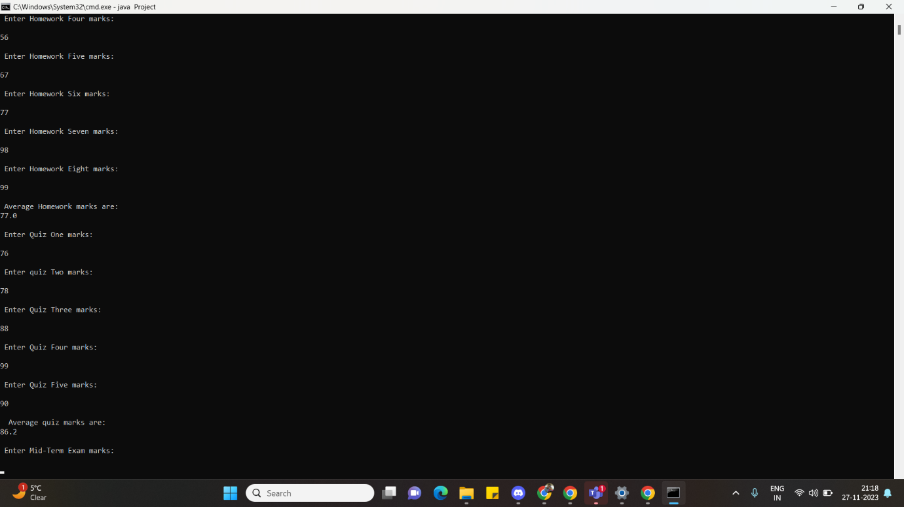

In this we can enter a particular student assignment marks.

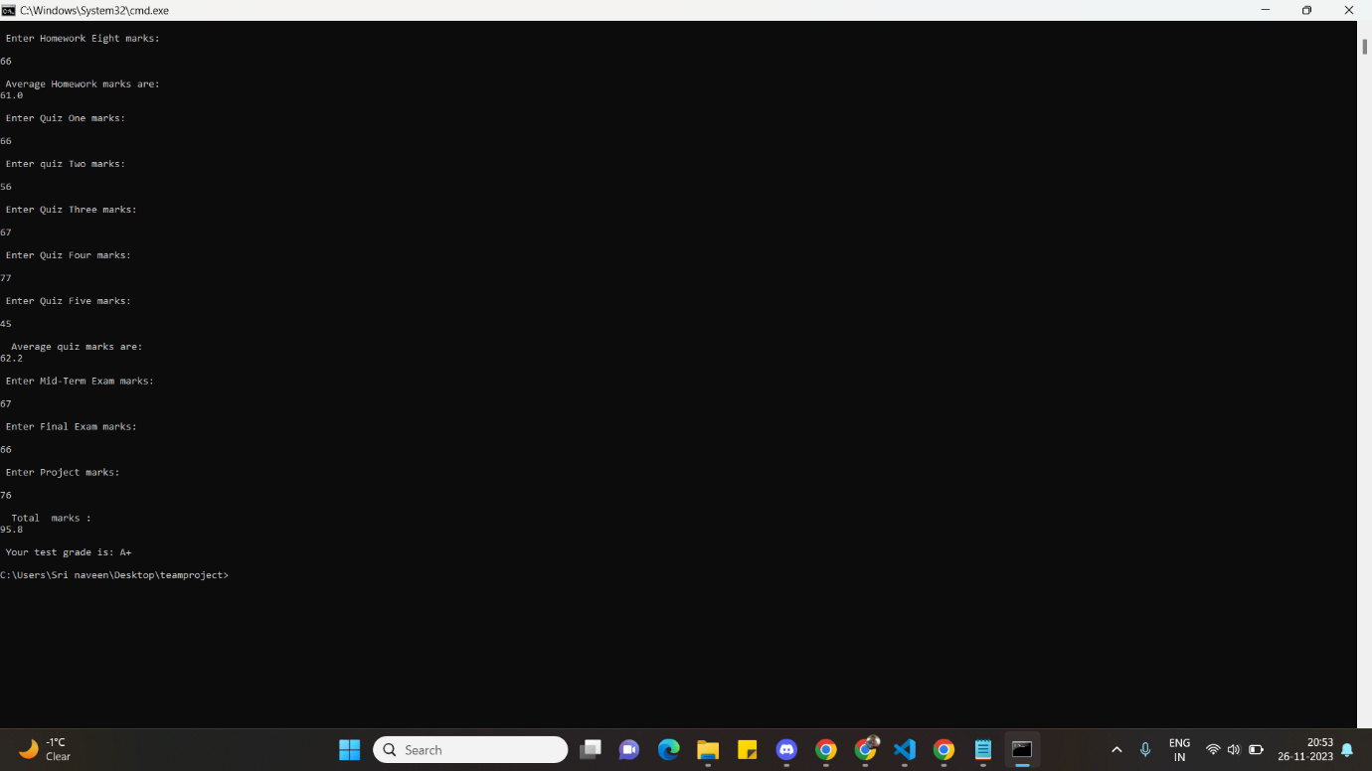In this we can analysis the score of the student as well as of overall performance

Class Diagram for Student Grading System

|  |
| --- |
| -letterGrade: char  -homeworkOne: double  -homeworkTwo: double  -homeworkThree: double  -homeworkFour: double  -quizOne: double  -quizTwo: double  -quizThree: double  -quizFour: double  -quizFive: double  -midTerm: double  -finalExam: double  -finalProject: double |
| +avgHomework(): double  +avgQuiz (): double  +avgmidTerm(): double  +avgfinalExam(): double  +avgProject(): double |

|  |
| --- |
| Home Work |
| -homeOne: double  -homeTwo: double  -homeThree: double  -homeFour: double |
| +avgHomework(): double |

|  |
| --- |
| Quiz |
| -quiz1: double  -quiz2: double  -quiz3: double  -quiz4: double |
| +avgQuiz (): double |

|  |
| --- |
| MidTerm |
| -midTerm: double |
| +avgmidTerm(): double |

|  |
| --- |
| Final Exam |
| -finalExam: double |
| +avgfinalExam(): double |

|  |
| --- |
| Project |
| -finalProject: double |
| +avgfinalProject(): double |

|  |
| --- |
| Course Grade |
| -Total: double |
| +letterGrade(): char |